Julius Ranoa

CSC 121 001 Computer Science I

Homework. Part 1.

Chapter 2. Page 70. Qn. 9 – 14, 17, 18.

1. Indicate if each of the following assignment statements is valid or invalid.
   1. total = 9; VALID.
   2. 72 = amount; INVALID. The literal should be in the right side of the assignment operator.
   3. yourAge = myAge; VALID assuming yourAge and myAge have similar data types.
2. If the variables letter and w have been defined as character variables, indicate if each of the following assignment statements is valid or invalid.
   1. letter = w; VALID.
   2. letter = ‘w’; VALID. Though, the value being assigned is a character literal.
   3. letter = “w”; INVALID. The value being assigned is a string literal, not a character one.
3. Indicate if each of the following cout statements is valid or invalid.
   1. cout << “Hello” << endl; VALID
   2. cout << “Hello” << /n; INVALID.
   3. cout << Hello; INVALID unless Hello is defined as either a character or string variable.
4. Indicate if each of the following cout statements is valid or invalid.
   1. cout << “Hello world”; VALID.
   2. cout << Hello world; INVALID.
   3. cout << “Hello” << “ world”; VALID.
5. Assume integers x = 4, y = 7, and z = 2. What value will be stored in the integer variable result by each of the following statements?
   1. result = x + y; 11
   2. result = y \* 2; 14
   3. result = y / z; 3
6. Assume double variables x = 2.5, y = 7.0, and z = 3. What value will be stored in integer variable result by each of the following statements?
   1. result = x + y; 9.5
   2. result = y \* 2; 14.0
   3. result = y / z; 2.3333
7. Write assignment statements that perform the following operations with int variable I, double variables d1 and d2, and char variable c.
   1. Add 2 to d1 and store the result to d2.  
      d2 = d1 + 2;
   2. Multiple d2 times 4 and store the result in d1.  
      d1 = d2 \* 4;
   3. Store the character ‘K’ in c.  
      c = ‘K’;
   4. Store the ASCII code for the character ‘K’ in i.  
      i = ‘K’;
   5. Subtract 1 from I and store the result back in i.  
      i = i – 1;
8. Write assignment statements that perform the following operations with int variable I, double variables d1 and d2, and char variable c.
   1. Subtract 8.5 from d2 and store the result in d1.  
      d1 = d2 – 8.5;
   2. Divide d1 by 3.14 and store the result in d2.  
      d2 = d1 / 3.14;
   3. Store the ASCII code for the character ‘F’ in c.  
      c = ‘F’
   4. Add 1 to i and store the new value back in i.  
      i = i + 1;
   5. Add d1 to the current value of d2 and store the result back in d2 as its new value.  
      d2 = d2 + d1;

Homework. Part 2.

Chapter 2. Page 74. Qn. 3 Sales Tax.

Files:

1. main.cpp
2. TaxCalculator.h
3. TaxCalculator.cpp

Screenshot of Execution:

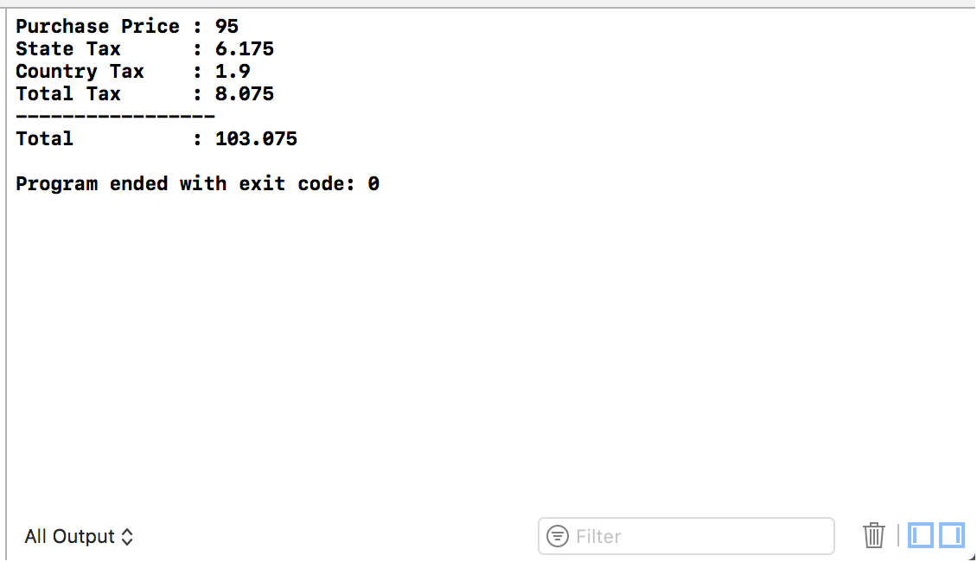

Source Code:

main.cpp



TaxCalculator.h



TaxCalculator.cpp

